Tennis Prediction Engine
Problem Area: Predictive Analytics
Problem Statement: Using purely human intuition, analysing tennis match outcomes can be time-consuming and inconsistent.

Analysis

Real-world use cases
To understand the problem area, and the requirements/constraints it presents, I researched 2 practical applications of match prediction.

Broadcast/media analytics for viewers
Win probability displays and predictions prior to tournaments are commonplace nowadays, and algorithms that power these are often required to be real-time, indicating that for some use cases, there is a constraint on the efficiency of such models.
For example, during the Wimbledon Grand Slam, the IBM Watson model combines both past results, and live point-by-point data to deliver real-time projections of who is likely to triumph – however, it is not infallible, and this achieves up to 66% accuracy on average, between both WTA and ATP matches. This means that a possible accuracy requirement for the product would have to be set moderately low, essentially to ~60%.

Talent identification and coaching
Studies researching machine learning applications in optimising performance (Sampaio, Oliveira, Marinho, Neiva, & Morais, 2024), have achieved up to 90.4% accuracy in predicting future high performers with logistic regression, and 93-99% accuracy in prediction of Grand Slam match winners using Decision Trees. This might be used by companies sponsoring players, for example, to calculate ROI, or for players to adjust their tactics, for example, whether to serve wide or down the T based on past results. This suggests that there are large financial incentives to building accurate prediction models, and that automated methods have a part to play in the data-driven evaluation of player performance.

Techniques

Logistic regression
Methods of modelling outcomes of tennis matches have progressed significantly over time. Initially, models such as Logistic Regression were used for their low complexity, and the fact that they were designed for such binary classification problems (Friligkos, Papaioannou, & Kaklamanis, 2023). Essentially, this involves fitting a sigmoid curve (logistic, S-shaped curve) to a dataset. As an input, some linear combination of the features would be used ($b_{0}+b_{1}x_{1}+b_{2}x_{2}…b_{n}x_{n}$), and the output of the model was compared to a certain threshold to determine the predicted result. This strategy would grasp simple relationships (for example, correlating higher rank to higher win probability), however, non-linearity (for example, the impact of the playing surface) would not be captured. Aside from this, it required a numerical encoding of categorical data, which often leads to issues with models assuming some form of ordinality where it doesn’t exist.

Decision trees
Similar to logistic regression, decision trees are supervised learning algorithms specifically for classification. It can be thought of as a flowchart, asking binary questions at each node, following the respective path, until a leaf is reached containing the eventual classification. To build a decision tree, a training set of features and labels is passed into the constructor, and a certain threshold value for a certain feature is chosen to split. Data that falls below the threshold (and the respective labels) is used to build the left subtree (recursively), and the rest is for the right subtree.
When handling categorical data, the standard approach is one-hot encoding. For example, instead of one feature named ‘Surface’ which can be ‘Hard’, ‘Clay’, ‘Grass’, there would be 3 features: ‘Surface_Hard’, ‘Surface_Clay’, ‘Surface_Grass’, with a 1 located in the correct feature. This prevents the ordinality issue of numerical encoding and prevents an exponential time complexity in considering all splits for a certain category ($2^{k}-1$ splits for a feature of $k$ categories).
To decide on this best split, there exist several different metrics, with the 2 most common being entropy, and Gini impurity.
Entropy can be thought of as measuring ‘how many bits are needed, on average, to represent a certain label using an optimal encoding?’ (assuming base 2). As a result, entropy heavily favours splits which reduce the variation in output labels, eventually reaching a minimum value of 0 when all labels are of a single category. In practice, however, it is computationally expensive as it requires computing logarithms for every element in the probability distribution.
Gini impurity, on the other hand, simply sums the of squares of each probability, and subtracts this value for one. Intuitively, if you randomly sampled one element, and randomly sampled one of the labels, the probability of the label being incorrect is the Gini impurity.
Decision trees, however, are incredibly sensitive to changes in the training data, often leading to significant overfitting, and creating overly complex trees that do not generalise well outside of training. Techniques to combat this, such as enforcing a maximum depth, or a minimum gain when making a split, can help to reduce this, but the greedy nature of the algorithm (making locally optimal decisions at each node) means that it is difficult to directly remove.

Random Forest
This is a type of ensemble learning algorithm to tackle the limitations of the decision tree. As the name suggest, it is composed of many decision trees, each trained on some random subset taken from the full training data (with replacement), with the hope being that this leads to different features being considered, and allows interactions missed by a single decision tree. For example, one tree may start with break point conversion, and another tree with the Elo ranking difference. A vote across all decision trees creates a probability distribution across categories, and the one with the highest probability is selected (argmax). This can also serve as a confidence metric of sorts – whether the decision was unanimous across most trees, or more evenly spread.

Choice
Based on my research, an implementation of a Random Forest algorithm would be achievable (compared to larger time-series based deep learning models), robust and generalisable.

Prototype of critical path
As a proof-of-concept, I will implement a simple Decision Tree.
This implements the key algorithms (entropy calculation, data splitting, prediction), however it will need to be fully encapsulated and potentially optimised.
import numpy as np
​
​
#####################
# Utility functions #
#####################
​
def entropy(y):
# Get the different classes that exist in the output, and their counts
classes, counts = np.unique(y, return_counts=True)
# Turn in to probability distribution (sums to 1)
prob = counts / counts.sum()
# We want to penalise having an even distribution - we prefer the data to be mostly in a specific class
# We calculate the average number of bits (log2) needed to describe the class of a random sample
return -np.sum(prob * np.log2(prob))
​
#####################
# Helper structures #
#####################
​
class DecisionNode:
def __init__(self, feature, threshold, left, right, value=None):
self.feature = feature # The index of the feature we split our data on
self.threshold = threshold # If under threshold, go to left node, otherwise right node
self.left = left # The left node
self.right = right # The right node
self.value = value # If this is a leaf node, the predicted class
​
def __str__(self, depth=0):
indent = " " * depth
if self.is_leaf():
return f"{indent}Leaf(value={self.value})"
​
s = f"{indent}Node(feature={self.feature}, threshold={self.threshold:.4f})\n"
s += self.left.__str__(depth + 1) + "\n"
s += self.right.__str__(depth + 1)
return s
​
@staticmethod
def make_leaf(value):
return DecisionNode(None, None, None, None, value)
​
def is_leaf(self):
return self.value is not None
​
######################
# Main class + logic #
######################
​
class DecisionTree:
def __init__(self, x, y, max_depth=None, min_gain=1e-7):
self.root = DecisionTree._build(x, y, 0, max_depth, min_gain)
​
@staticmethod
def _best_split(x, y, min_gain):
n_samples, n_features = x.shape
​
best = {
'feature' : None,
'threshold' : None,
'gain' : min_gain,
# Caching for performance
'masks' : (None, None),
'y_split' : (None, None)
}
old_entropy = entropy(y)
​
for feature in range(n_features):
values = np.sort(np.unique(x[:, feature]))
# Average between adjacent values
thresholds = (values[:-1] + values[1:]) / 2
​
for t in thresholds:
left_mask = x[:, feature] <= t
right_mask = x[:, feature] > t
​
# If none of the data is contained in one of the masks, then this is a useless threshold
if not any(left_mask) or not any(right_mask):
continue
​
y_left, y_right = y[left_mask], y[right_mask]
​
# .mean() on a boolean mask gets what fraction of the values are put into mask
# We use it as our weight (left_mask.mean() + right_mask.mean() == 1)
new_entropy = (left_mask.mean() * entropy(y_left) +
right_mask.mean() * entropy(y_right))
​
# The gain is just the reduction in entropy
gain = old_entropy - new_entropy
if gain > best['gain']:
best['feature'] = feature
best['threshold'] = t
best['gain'] = gain
best['masks'] = (left_mask, right_mask)
best['y_split'] = (y_left, y_right)

return best
​
@staticmethod
def _build(x, y, depth, max_depth, min_gain):
# If we've gone to our maximum depth, or we've only got 1 remaining class
classes, counts = np.unique(y, return_counts=True)
if (max_depth is not None and depth >= max_depth) or len(classes) == 1:
# We use the highest count to choose our value at the end
return DecisionNode.make_leaf(classes[np.argmax(counts)])

best = DecisionTree._best_split(x, y, min_gain)
# No useful splits
if best['gain'] <= min_gain:
return DecisionNode.make_leaf(classes[np.argmax(counts)])
​
left_mask, right_mask = best['masks']
y_left, y_right = best['y_split']

left = DecisionTree._build(x[left_mask], y_left, depth + 1, max_depth, min_gain)
right = DecisionTree._build(x[right_mask], y_right, depth + 1, max_depth, min_gain)
​
return DecisionNode(
best['feature'],
best['threshold'],
left,
right,
)
​
@staticmethod
def _predict_helper(node, x):
if node.is_leaf():
return node.value

return DecisionTree._predict_helper(
node.left if x[node.feature] <= node.threshold else node.right,
x
)

def predict(self, x):
return np.array([DecisionTree._predict_helper(self.root, xr) for xr in x])

Using this simple implementation, I tested against a simplistic dataset known as ‘Iris’ focussed on classification of flowers based on measurements.
import numpy as np
from sklearn.datasets import load_iris
from sklearn.model_selection import train_test_split
import minforest as mf
​
if __name__ == "__main__":
iris = load_iris()
print(iris.DESCR)
x = iris.data.astype(np.float32)
y = iris.target.astype(np.int32)
​
​
x_train, x_test, y_train, y_test = train_test_split(x, y, test_size=0.2, random_state=42)

tree = mf.DecisionTree(x, y)
​
print(tree.root)
preds = tree.predict(x_test)
print(np.mean(preds == y_test))
Upon execution, this produced the following tree:
Node(feature=2, threshold=2.4500)
Leaf(value=0)
Node(feature=3, threshold=1.7500)
Node(feature=2, threshold=4.9500)
Node(feature=3, threshold=1.6500)
Leaf(value=1)
Leaf(value=2)
Node(feature=3, threshold=1.5500)
Leaf(value=2)
Node(feature=0, threshold=6.9500)
Leaf(value=1)
Leaf(value=2)
Node(feature=2, threshold=4.8500)
Node(feature=0, threshold=5.9500)
Leaf(value=1)
Leaf(value=2)
Leaf(value=2
This achieves an accuracy of 100% on the test dataset, and captures key features, such petal length being less than 2.45 directly corresponding to Setosa.

Objectives
Having researched the problem area to understand use cases, SOTA models, and limitations, I set out the following objectives:
- Build a Random Forest based prediction engine capable of taking in information about a match and outputting a result.
- Ensure the prediction engine is robust and relatively efficient (<0.5s for inference, no requirements set for training).
- Validate and benchmark it on existing datasets (e.g. those collected by Tennis Abstract).
- Achieve reasonable predictions (~60% based on size of dataset)
- Ensure a modular design so it is simple to integrate in any system.\

Documented design
By use of a Hierarchy Chart, I decomposed the Prediction Engine into 4 main subproblems:
- Data acquisition: Collection, aggregation, and preprocessing of data for use in the model.
- Feature engineering: Deriving relevant variables/metrics from data to provide to model.
- Random forest model: The actual implementation of the Random Forest algorithm.
- Evaluation: Calculating accuracy, getting probability scores, and backtesting on past seasons.
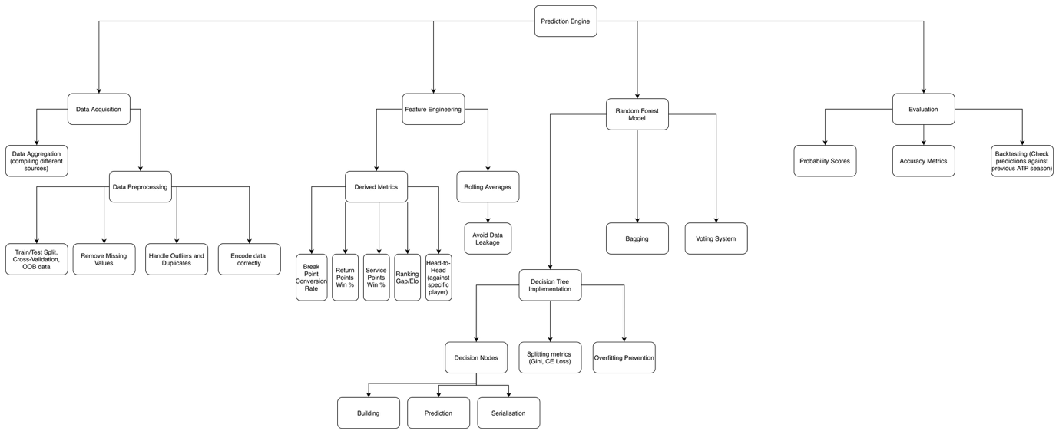

Data structures
Next, I designed a Class Diagram to represent the different objects and relationships used to model the problem.
With the Decision Tree implementation, as different data and behaviour is required by each Decision Node, but they need to share a common interface, I have used inheritance from a parent class. This allows for runtime polymorphism, used in the IsLeaf and String abstract methods.
Additionally, the lifetime of these nodes should be directly tied to the that of the outer decision tree, so I have opted for composition.

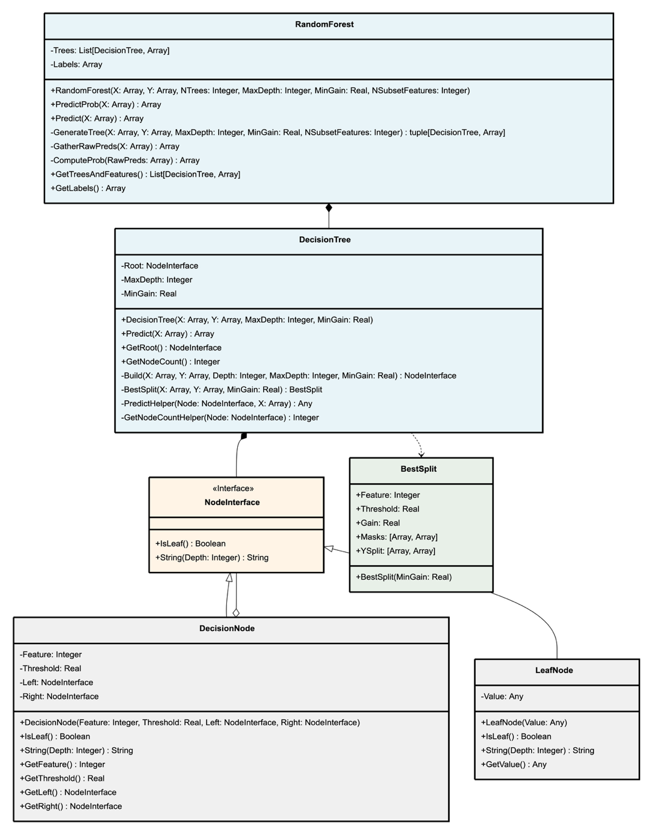
Aside from this, I have defined both the public/private method interface, some of which were present in the prototype of the critical path, but I have fully encapsulated state of each node, along with the full decision tree, using getters to provide a view of the data, without allowing direct modification.

Algorithms
The two flowcharts below describe (at a high level) the process of entropy calculation and finding the best feature and threshold to split on, which involves looping through thresholds to find the split which maximises reduction in entropy.
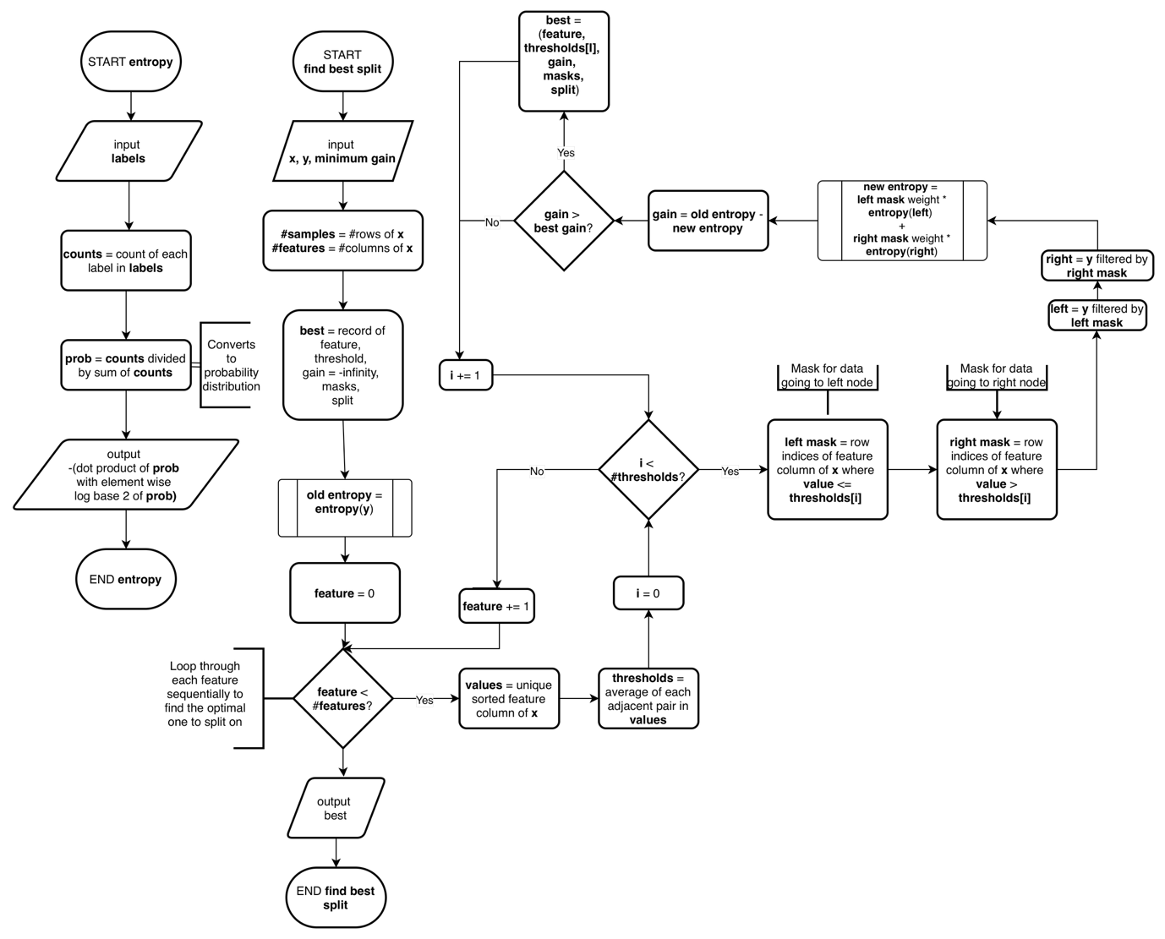

Using these subroutines, I proceeded to design the Decision Tree building algorithm at a higher level. At each stage, a threshold and feature is computed with the Best Split function defined above, which allows for a left/right subtree to be built recursively, or to create a leaf from the most common label if entropy reduction is negligible, reducing tree complexity and improving efficiency.
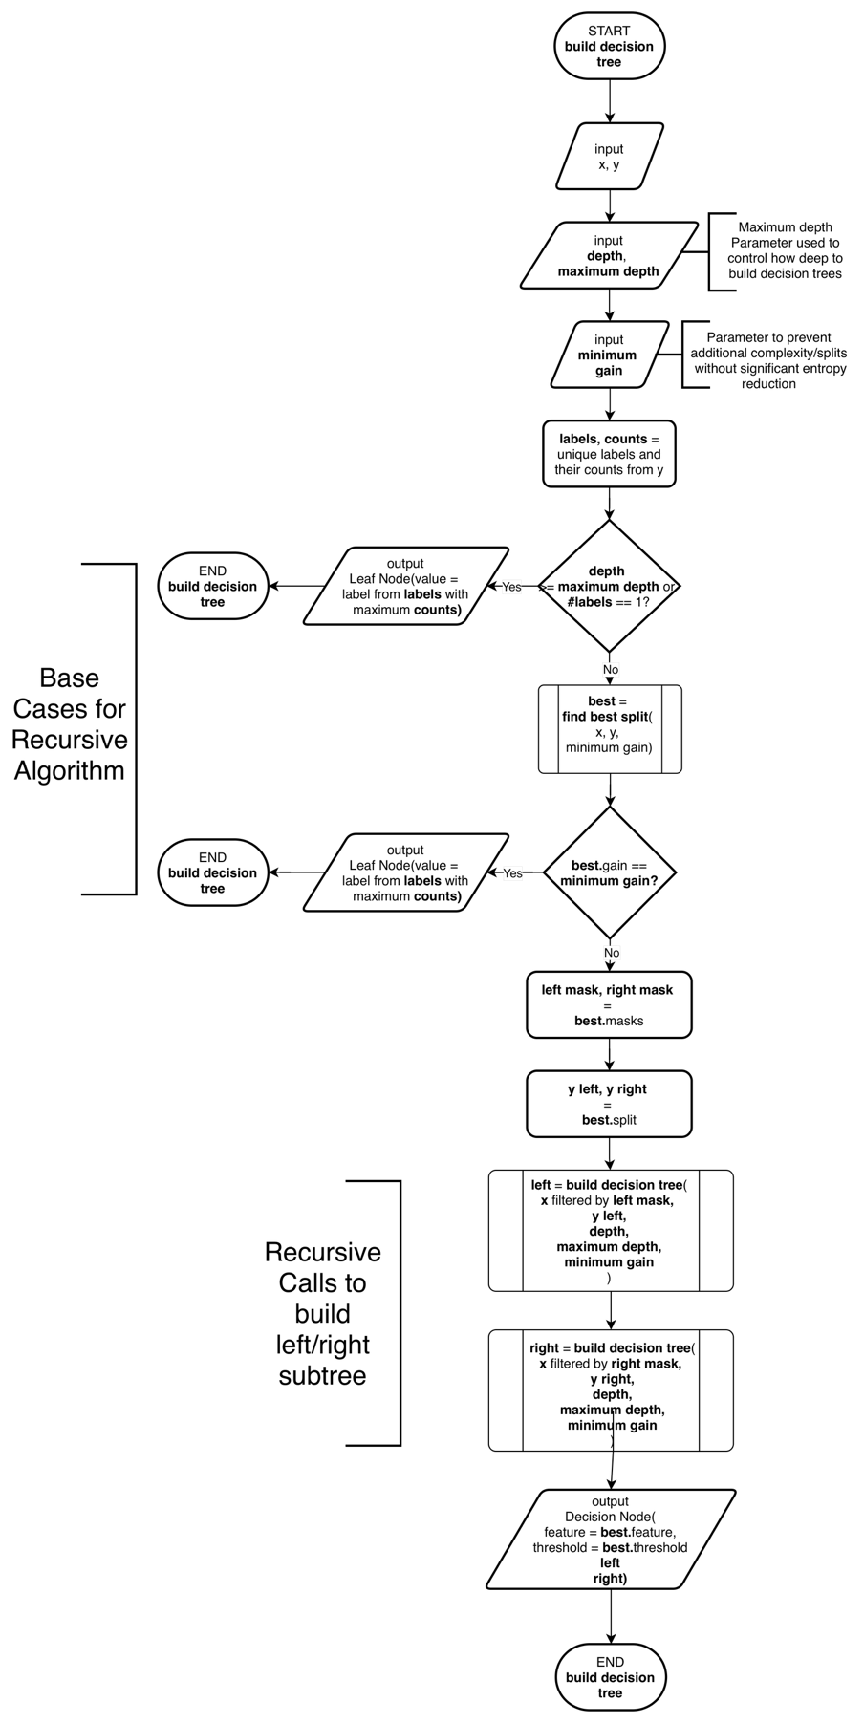
To make predictions using the Decision Tree, a recursive depth-first traversal algorithm can be used to conditionally travel down the left/right edge depending on how the feature compares to the threshold.

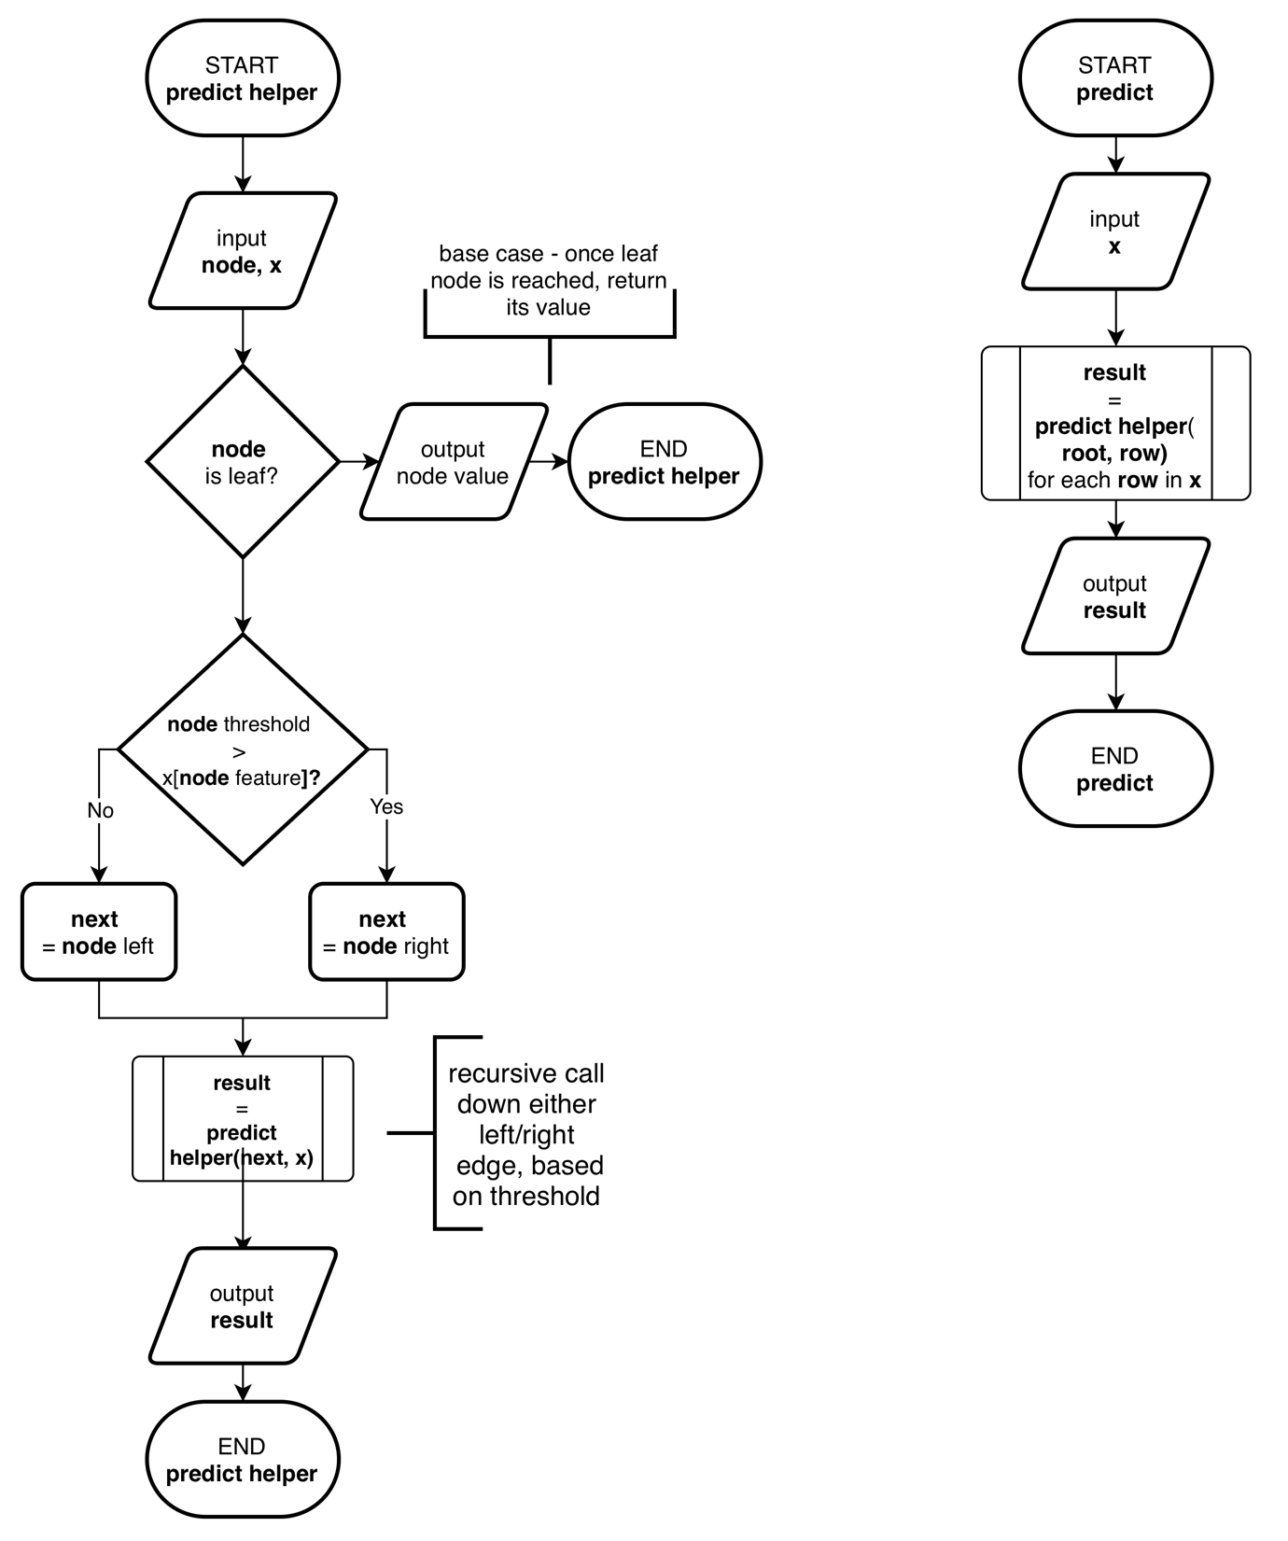

Given that decision trees can now be built easily, I outlined the core bagging (bootstrap aggregation – technique for sampling training data for use in a decision tree), and voting algorithms used in Random Forest prediction.
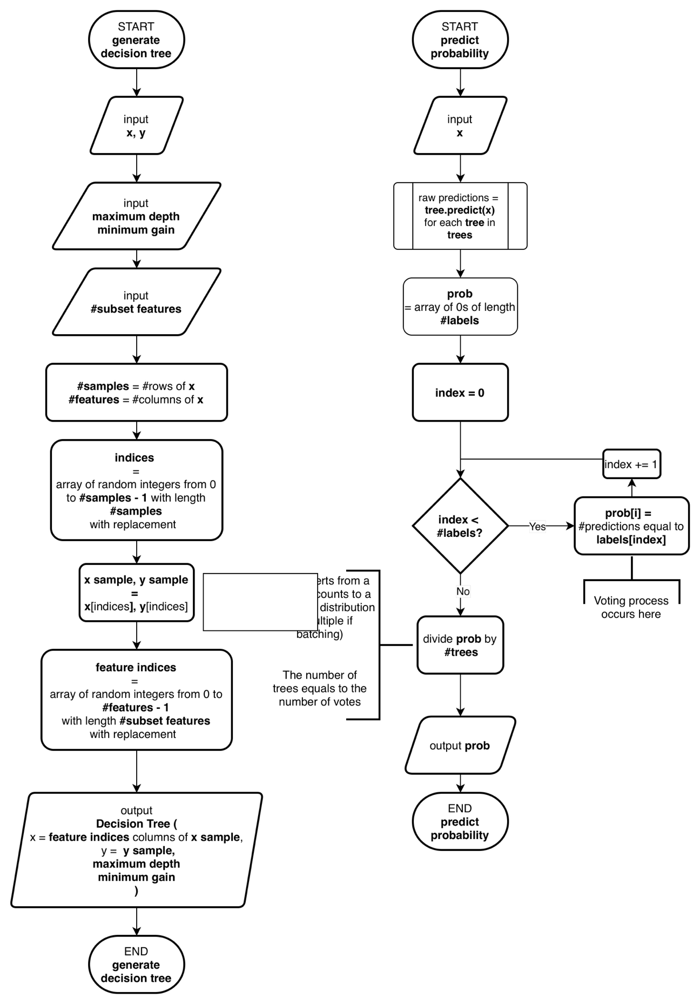

Technical solution

Data pipeline
Firstly, I worked on setting up a reliable data pipeline that can be adapted based on training results. Initially, I built a rough prototype in a Jupyter notebook (available in the project repository), computing different derived metrics.
Takeaways from this included:
- Rolling statistics and differentials are key to compressing the number of features to train on while retaining all information – the relative difference between 2 players’ stats can be all that is necessary for high-quality prediction.
- Rolling statistics and time-series data must be performed with a minimum period before being considered accurate, otherwise this increases noise and reduces training ability.
- A good strategy for amending missing values must be adopted – simply averaging or taking median works in most cases, but it is often more accurate to use player/surface-specific averages.
- A flexible configuration scheme is necessary to allow for efficient testing and improve the modular design.
- Ensuring input validation and a logging system will allow errors to be easily pinpointed.
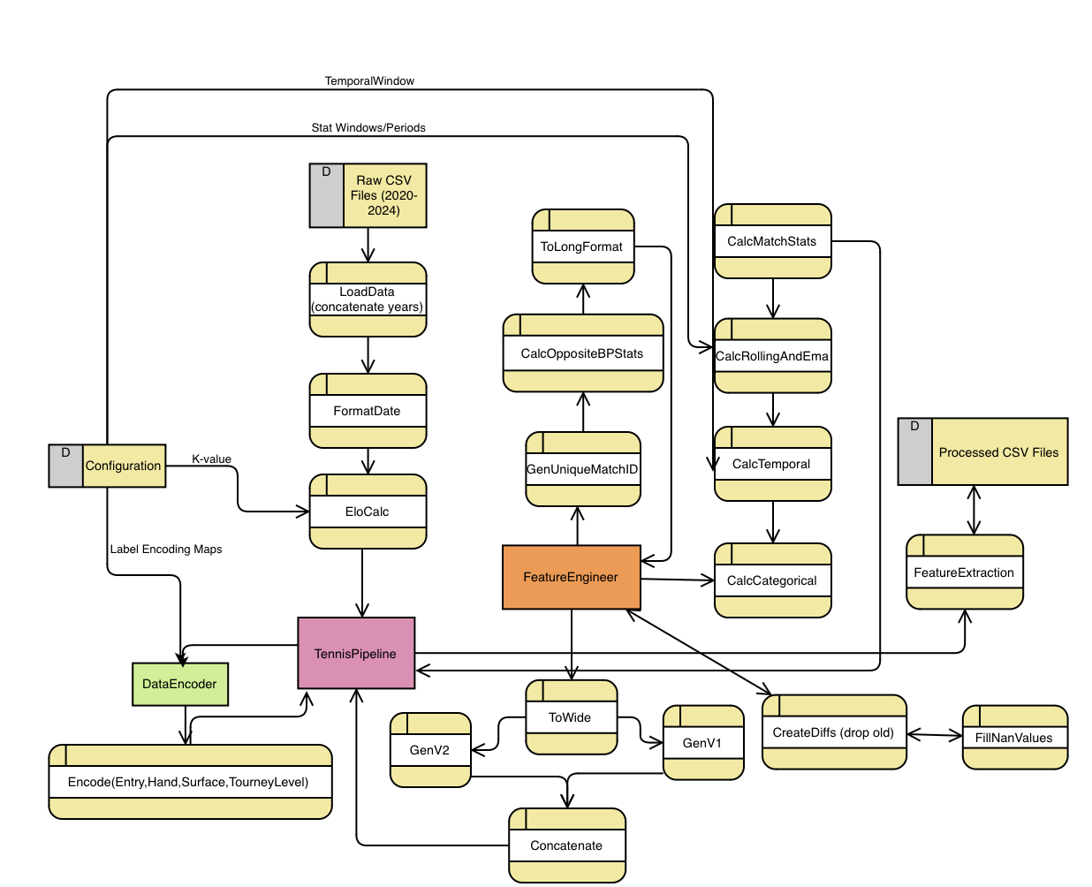
Given this, I created a simple data-flow diagram to outline, at a high level, the processes involved:

The code was split into 5 modules – Configuration, Data Encoder, Feature Engineer, Tennis Pipeline and Main.
Below are their implementations:
config.py
import numpy as np
​
# Input/output paths
INPUT_DIRECTORY = 'tennis_atp'
OUTPUT_DIRECTORY = 'processed_data'
​
# Years used for training - upper bound is exclusive
YEARS = range(2020, 2025)
​
# Elo parameters
INITIAL_ELO = 1200 # The starting Elo value
K_FACTOR = 40 # The maximum increase/decrease in rating from 1 match
​
# Rolling config - represented as a dictionary of dictionaries
ROLLING_CONFIG = {
'serve_win_ratio' : { 'window' : 10, 'min_periods' : 2},
'first_serve_ratio' : { 'window' : 10, 'min_periods' : 2},
'first_serve_win_ratio' : { 'window' : 10, 'min_periods' : 2},
'bp_conversion' : { 'window' : 10, 'min_periods' : 2},
'bp_save_rate' : { 'window' : 10, 'min_periods' : 2},
'ace_rate' : { 'window' : 10, 'min_periods' : 2},
'double_fault_rate' : { 'window' : 10, 'min_periods' : 2},
}
SURFACE_WIN_RATIO_CONFIG = { 'window' : 10, 'min_periods' : 2 }
​
​
# Exponential moving-average for current form
RECENT_FORM_EMA_SPAN = 5
RECENT_FORM_EMA_MIN_PERIODS = 3
​
# How far to look back when considering a win streak
WIN_STREAK_WINDOW = 10
​
# How many days to look back when calculating rank changes
RANK_LOOKBACK_DAYS = 30
​
# On a player's first match in the dataset, what is their previous match?
DEFAULT_DAYS_SINCE_MATCH = 14
​
# Numerical label encoding - these are ordinal, which works fine for Decision Trees
ENTRY_TYPE_MAP = {
np.nan : 0, # Standard entry
'SE' : 1, # (S)pecial (E)xempt
'PR' : 2, # (P)rotected (R)anking
'UP' : 2, # (U)sed (P)rotection - similar to PR, tends to be high class players
'Q' : 3, # (Q)ualifier
'WC' : 4, # (W)ild (C)ard
'LL' : 5, # (L)ucky (L)oser
'Alt' : 6, # (Alt)ernate
'ALT' : 6, # (ALT)ernate
'ITF' : 6, # ITF tour - generally newer players, unfavourable
'W' : 6
}
​
# Encodings for surfaces
SURFACE_MAP = {
np.nan : 0,
'Hard' : 1,
'Clay' : 2,
'Grass' : 3
}
​
# Tournament mapping - from most to least prestigious
TOURNAMENT_LEVEL_MAP = {
'G': 0, # Grand Slam
'F': 1, # Finals
'M': 2, # Masters
'A': 3, # ATP Tour
'O': 4, # Other
'D': 5 # Davis Cup
}
​
# All columns available in the unprocessed dataset
COLUMN_NAMES = [
'tournament_id',
'tournament_name',
'surface',
'draw_size',
'tournament_level',
'tournament_date',
'match_number',
'winner_id',
'winner_seed',
'winner_entry_type',
'winner_name',
'winner_hand',
'winner_height_cm',
'winner_country_code',
'winner_age',
'loser_id',
'loser_seed',
'loser_entry_type',
'loser_name',
'loser_hand',
'loser_height_cm',
'loser_country_code',
'loser_age',
'score',
'best_of_sets',
'round',
'match_duration_minutes',
'winner_aces',
'winner_double_faults',
'winner_service_points_played',
'winner_first_serves_in',
'winner_first_serve_points_won',
'winner_second_serve_points_won',
'winner_service_games_played',
'winner_break_points_saved',
'winner_break_points_faced',
'loser_aces',
'loser_double_faults',
'loser_service_points_played',
'loser_first_serves_in',
'loser_first_serve_points_won',
'loser_second_serve_points_won',
'loser_service_games_played',
'loser_break_points_saved',
'loser_break_points_faced',
'winner_rank',
'winner_rank_points',
'loser_rank',
'loser_rank_points'
]
​
NEUTRAL_COLUMNS = [
'unique_match_id',
'tournament_date',
'surface',
'tournament_level',
'best_of_sets'
]
​
# Columns which should be relative rather than separate for A and B
DIFFERENTIAL_COLUMNS = [
'rank',
'rank_points',
'elo',
'age',
'height_cm',
'rolling_serve_win_ratio',
'rolling_first_serve_ratio',
'rolling_first_serve_win_ratio',
'rolling_bp_conversion',
'rolling_bp_save_rate',
'rolling_surface_win_ratio',
'rolling_ace_rate',
'rolling_double_fault_rate',
'recent_form_ema',
'win_streak',
'rank_change_30d',
'days_since_last_match',
]
​
# Final feature columns for model training
FEATURE_COLUMNS = [
'A_entry_type',
'A_hand',
'A_has_seed',
'B_entry_type',
'B_hand',
'B_has_seed',
'surface',
'tournament_level',
'best_of_sets',
'rank_diff',
'rank_points_diff',
'elo_diff',
'age_diff',
'height_cm_diff',
'rolling_serve_win_ratio_diff',
'rolling_first_serve_ratio_diff',
'rolling_first_serve_win_ratio_diff',
'rolling_bp_conversion_diff',
'rolling_bp_save_rate_diff',
'rolling_surface_win_ratio_diff',
'rolling_ace_rate_diff',
'rolling_double_fault_rate_diff',
'recent_form_ema_diff',
'win_streak_diff',
'rank_change_30d_diff',
'days_since_last_match_diff'
]
​
# Numeric columns that may have NaN values to average out...
NUMERIC_NAN_COLUMNS = [
'ace_rate',
'aces',
'age',
'bp_conversion',
'bp_save_rate',
'break_points_faced',
'break_points_saved',
'double_fault_rate',
'double_faults',
'first_serve_points_won',
'first_serve_ratio',
'first_serve_win_ratio',
'first_serves_in',
'height_cm',
'rank',
'rank_points',
'recent_form_ema',
'rolling_bp_conversion',
'rolling_bp_save_rate',
'rolling_first_serve_ratio',
'rolling_first_serve_win_ratio',
'rolling_serve_win_ratio',
'rolling_surface_win_ratio',
'rolling_ace_rate',
'rolling_double_fault_rate',
'second_serve_points_won',
'second_serve_win_ratio',
'serve_win_ratio',
'service_games_played',
'service_points_played',
'win_streak'
]
​
DEFAULT_DAYS_SINCE_LAST_MATCH = 14

data_encoder.py
import pandas as pd
import numpy as np
import logging
​
import config
​
class DataEncoder:
"""
Encodes categorical to numeric values
"""

def encode_entry_type(self, df):
logging.info('\tEncoding entry type')
df['entry_type'] = df['entry_type'].map(config.ENTRY_TYPE_MAP)
return df

def encode_hand(self, df):
logging.info('\tEncoding hand')
df['hand'] = (df['hand'] == 'R').astype(int)
return df

def encode_surface(self, df):
logging.info('\tEncoding surface')
df['surface'] = df['surface'].map(config.SURFACE_MAP)
return df

def encode_tournament_level(self, df):
logging.info('\tEncoding tournament level')
df['tournament_level'] = df['tournament_level'].map(config.TOURNAMENT_LEVEL_MAP)
return df

def encode_all(self, df):
df = self.encode_entry_type(df)
df = self.encode_hand(df)
df = self.encode_surface(df)
df = self.encode_tournament_level(df)
return df

feature_engineer.py
import pandas as pd
import logging
​
import config
​
class FeatureEngineer:
"""
Creates features from raw match data
"""
​
def create_unique_match_id(self, matches):
matches['unique_match_id'] = matches['tournament_id'] + '_' + matches['match_number'].astype(str)
return matches
​
def create_opposite_bp_stats(self, matches):
# These stats depend on opposite player's break point stats, so need to be processed in wide format
matches['winner_bp_conversion'] = (
matches['loser_break_points_faced'] - matches['loser_break_points_saved']
) / matches['loser_break_points_faced']

matches['loser_bp_conversion'] = (
matches['winner_break_points_faced'] - matches['winner_break_points_saved']
) / matches['winner_break_points_faced']
return matches

def convert_to_long_format(self, matches):
''
logging.info('Converting matches to long format')

neutral_columns = config.NEUTRAL_COLUMNS.copy()

# Prepare winner data
winner_columns = [col for col in matches.columns if 'winner' in col] + neutral_columns
winners = matches[winner_columns].copy()
winners.columns = [col.replace('winner_', '') for col in winners.columns]
winners['outcome'] = 1

# Prepare loser data
loser_columns = [col for col in matches.columns if 'loser' in col] + neutral_columns
losers = matches[loser_columns].copy()
losers.columns = [col.replace('loser_', '') for col in losers.columns]
losers['outcome'] = 0

# Combine and sort
long_data = pd.concat([winners, losers], ignore_index=True)
long_data = long_data.sort_values(['tournament_date', 'unique_match_id'])

logging.info(f'Long format created: {len(long_data)} player-match records')

return long_data
​
def convert_to_wide_format(self, long_data):
logging.info('\tConverting back to wide format...')
player_columns = [col for col in long_data.columns if col not in config.NEUTRAL_COLUMNS and col not in ['id', 'country_code', 'outcome']]
winners = long_data[long_data['outcome'] == 1]
losers = long_data[long_data['outcome'] == 0]
​
# We generate 2 copies of each match - with A and B swapped, to prevent
v1_winners = winners.rename(columns={col: 'A_' + col for col in player_columns})
v1_losers = losers.rename(columns={col: 'B_' + col for col in player_columns})
​
wide_v1 = pd.merge(
v1_winners[config.NEUTRAL_COLUMNS + ['A_' + col for col in player_columns]],
v1_losers[['unique_match_id'] + ['B_' + col for col in player_columns]],
on='unique_match_id'
)
wide_v1['target'] = 1

v2_losers = losers.rename(columns={col: 'A_' + col for col in player_columns})
v2_winners = winners.rename(columns={col: 'B_' + col for col in player_columns})

wide_v2 = pd.merge(
v2_losers[config.NEUTRAL_COLUMNS + ['A_' + col for col in player_columns]],
v2_winners[['unique_match_id'] + ['B_' + col for col in player_columns]],
on='unique_match_id'
)
wide_v2['target'] = 0
​
logging.info(f'\tWide format created: {len(wide_v1) * 2} match records')
​
return pd.concat([wide_v1, wide_v2], axis=0).reset_index(drop=False)
​
def create_differential_features(self, wide_data):
logging.info('\tCreating differential features...')
​
for column in config.DIFFERENTIAL_COLUMNS:
column_A = f'A_{column}'
column_B = f'B_{column}'
​
if column_A in wide_data.columns and column_B in wide_data.columns:
wide_data[f'{column}_diff'] = wide_data[column_A] - wide_data[column_B]
wide_data = wide_data.drop([column_A, column_B], axis=1)
​
else:
logging.warning(f'Could not create differential for {column}: missing {column_A} or {column_B}')
​
return wide_data
​
​
def create_match_statistics(self, long_data):
logging.info('\tGenerating serve/double fault/breakpoint statistics...')

long_data['serve_win_ratio'] = (
long_data['first_serve_points_won'] + long_data['second_serve_points_won']
) / long_data['service_points_played']

long_data['first_serve_ratio'] = (
long_data['first_serves_in']
) / long_data['service_points_played']

long_data['first_serve_win_ratio'] = (
long_data['first_serve_points_won']
) / long_data['first_serves_in']

second_serve_points = (
long_data['service_points_played'] -
long_data['first_serves_in'] -
long_data['double_faults']
)
​
long_data['second_serve_win_ratio'] = (
long_data['second_serve_points_won']
) / second_serve_points

long_data['ace_rate'] = (
long_data['aces']
) / long_data['service_points_played']

long_data['double_fault_rate'] = (
long_data['double_faults']
) / long_data['service_points_played']

long_data['bp_save_rate'] = (
long_data['break_points_saved']
) / long_data['break_points_faced']

return long_data
​
def create_rolling_features(self, long_data):
logging.info('\tGenerating rolling features...')
​
for stat, params in config.ROLLING_CONFIG.items():
if stat not in long_data.columns:
logging.warning(f"'{stat}' not found, ignoring!")
continue

long_data[f'rolling_{stat}'] = (
long_data.groupby('id')[stat]
.transform(
lambda x : x.shift(1).rolling(
params['window'],
min_periods=params['min_periods']
).mean()
)
)
​
long_data['rolling_surface_win_ratio'] = (
long_data.groupby(['id', 'surface'])['outcome']
.transform(
lambda x : x.shift(1).rolling(
config.SURFACE_WIN_RATIO_CONFIG['window'],
min_periods=config.SURFACE_WIN_RATIO_CONFIG['min_periods']
).mean()
)
)

return long_data

def create_momentum_features(self, long_data):
logging.info('\tGenerating momentum features...')

long_data['recent_form_ema'] = (
long_data.groupby('id')['outcome']
.transform(
lambda x : x.shift(1).ewm(
span=config.RECENT_FORM_EMA_SPAN,
min_periods=config.RECENT_FORM_EMA_MIN_PERIODS
).mean()
)
)

long_data['win_streak'] = (
long_data.groupby('id')['outcome']
.transform(
lambda x : x.shift(1).rolling(
config.WIN_STREAK_WINDOW,
min_periods=1
).sum()
)
)

return long_data

def create_time_specific_features(self, long_data):
logging.info('\tGenerating time-specific features...')

long_data['days_since_last_match'] = (
long_data.groupby('id')['tournament_date']
.diff()
.dt.days
.fillna(config.DEFAULT_DAYS_SINCE_LAST_MATCH)
)

long_data = self._add_rank_change_feature(long_data)

return long_data

def _add_rank_change_feature(self, long_data: pd.DataFrame) -> pd.DataFrame:
long_data_sorted = long_data.sort_values(['tournament_date', 'id']).copy()

lookup = long_data_sorted[['id', 'tournament_date', 'rank']].copy()
lookup['tournament_date'] = lookup['tournament_date'] + pd.Timedelta(days=config.RANK_LOOKBACK_DAYS)
lookup = lookup.rename(columns={'rank': 'rank_30d_ago'})

result = pd.merge_asof(
long_data_sorted,
lookup[['id', 'tournament_date', 'rank_30d_ago']],
on='tournament_date',
by='id',
direction='backward'
)
result['rank_change_30d'] = result['rank_30d_ago'] - result['rank']
result = result.drop('rank_30d_ago', axis=1)

return result
​
def create_categorical_features(self, long_data):
logging.info('\tGenerating categorical features')

# Binary indicator for seeded players
long_data['has_seed'] = long_data['seed'].notna().astype(int)
long_data = long_data.drop('seed', axis=1)

return long_data

def engineer_features(self, matches):
matches = self.create_unique_match_id(matches)
matches = self.create_opposite_bp_stats(matches)
long_data = self.convert_to_long_format(matches)

# Create features
long_data = self.create_match_statistics(long_data)
long_data = self.create_rolling_features(long_data)
long_data = self.create_momentum_features(long_data)
long_data = self.create_time_specific_features(long_data)
long_data = self.create_categorical_features(long_data)

return long_data
​
def fill_missing_values(self, long_data):
numeric_columns = config.NUMERIC_NAN_COLUMNS
​
logging.info('\tFilling missing values...')

existing_columns = [col for col in numeric_columns if col in long_data.columns]
missing_columns = set(numeric_columns) - set(existing_columns)
if missing_columns:
logging.info(f'\tColumns not found: {missing_columns}')

initial_nan_count = long_data[existing_columns].isna().sum().sum()
logging.info(f'\tInitial NaN count: {initial_nan_count:,}')

for col in existing_columns:
if long_data[col].isna().any():
long_data[col] = long_data.groupby('id')[col].transform(
lambda x: x.fillna(x.mean())
)

global_mean = long_data[col].mean()
long_data[col] = long_data[col].fillna(global_mean)

final_nan_count = long_data[existing_columns].isna().sum().sum()
logging.info(
f'NaN reduction: {initial_nan_count} -> {final_nan_count}'
)

return long_data

tennis_pipeline.py
import os
​
import numpy as np
import pandas as pd
​
import config
import logging
from feature_engineer import FeatureEngineer
from data_encoder import DataEncoder
​
#####################
# UTILITY FUNCTIONS #
#####################
​
def calculate_elo_features(matches, initial_elo, k_factor):
# Initial Elo
​
current_elos = {}
​
# This refers to the previous elo ranking (before the match)
winner_elos = []
loser_elos = []
​
for _, row in matches.iterrows():
winner_id, loser_id = row['winner_id'], row['loser_id']
​
winner_elo = current_elos.get(winner_id, initial_elo)
loser_elo = current_elos.get(loser_id, initial_elo)
winner_elos.append(winner_elo)
loser_elos.append(loser_elo)
​
# A sigmoidal (S-shaped) win probability prediction (a form of simplistic logistic regression)
win_prob = 1 / (1 + 10 ** ((loser_elo - winner_elo) / 400))
​
# The k-factor (the maximum rating change posssible) by the win probability
# I.e. if the winner was predicted as unlikely to do win, their rating change is much more significant
rating_change = k_factor * (1 - win_prob)
​
# Update Elos
current_elos[winner_id] = winner_elo + rating_change
current_elos[loser_id] = loser_elo - rating_change
​
matches['winner_elo'] = winner_elos
matches['loser_elo'] = loser_elos
​
​
#####################
# MAIN PIPELINE #
#####################
​
​
class TennisPipeline:
def __init__(self,
input_dir=config.INPUT_DIRECTORY,
output_dir=config.OUTPUT_DIRECTORY,
years=config.YEARS):
self.input_dir = input_dir
self.output_dir = output_dir
self.years = years
​
logging.getLogger().setLevel(logging.INFO)
​
logging.info('=' * 80)
logging.info('Tennis Data Pipeline')
logging.info('=' * 80)
​
logging.info(f'Input data directory: {os.path.relpath(input_dir)}')
logging.info(f'Output data directory: {os.path.relpath(output_dir)}')
logging.info(f'Years: {self.years.start}-{self.years.stop-1}')
​
def execute(self):
logging.info('Starting pipeline execution')
​
logging.info('=' * 80)
logging.info('Loading raw match data...')
​
matches = pd.concat([pd.read_csv(f'{self.input_dir}/atp_matches_{year}.csv') for year in self.years])
matches.columns = config.COLUMN_NAMES
matches['tournament_date'] = pd.to_datetime(matches['tournament_date'], format='%Y%m%d')
​
logging.info(f'Loaded DataFrame of shape {len(matches)} by {len(matches.columns)}')
logging.info(f'Memory usage: {matches.memory_usage(deep=True).sum() / (1024 * 1024):.2f}MB')
logging.info(f'NaN count: {matches.isna().sum().sum()}')
​
logging.info('=' * 80)
logging.info(f'Calculating Elo ratings (Initial={config.INITIAL_ELO}, K={config.K_FACTOR})...')
​
calculate_elo_features(matches, config.K_FACTOR, config.INITIAL_ELO)
​
logging.info('=' * 80)
logging.info('Feature engineering...')
​
engineer = FeatureEngineer()
long_data = engineer.engineer_features(matches)
​
logging.info('=' * 80)
logging.info('Performing label encoding...')
​
data_encoder = DataEncoder()
long_data = data_encoder.encode_all(long_data)
​
logging.info('=' * 80)
logging.info('Filling NaNs...')
​
long_data = engineer.fill_missing_values(long_data)
​
logging.info('=' * 80)
logging.info('Reverting to wide format...')
​
wide_data = engineer.convert_to_wide_format(long_data)
​
​
logging.info('=' * 80)
logging.info('Final feature processing...')
​
wide_data = engineer.create_differential_features(wide_data)
​
logging.info('=' * 80)
logging.info('Final stage - feature extraction...')
​
# Set exclusion operator to extract those that exist in feature columns, not in wide columns
missing_features = set(config.FEATURE_COLUMNS) - set(wide_data.columns)
if missing_features:
raise ValueError(f'Features are missing: {missing_features}')
​
x = wide_data[config.FEATURE_COLUMNS].copy()
y = wide_data['target'].copy()
​
logging.info('Done!')
logging.info('Features preview:')
logging.info(x.tail())
logging.info('Labels preview:')
logging.info(y.tail())
​
return x, y

def export(self, x, y):
logging.info("-" * 80)
logging.info("Saving final outputs to ")
logging.info("-" * 80)

# Save as CSV
features_path = f'{self.output_dir}/tennis_model_features.csv'
labels_path = f'{self.output_dir}/tennis_model_labels.csv'

x.to_csv(features_path, index=False)
y.to_csv(labels_path, index=False)

logging.info(f"Features saved: {features_path} ({os.path.getsize(features_path) / (1024 * 1024):.2f}MB)")
logging.info(f"Features saved: {labels_path} ({os.path.getsize(labels_path) / (1024 * 1024):.2f}MB)")

main.py

from tennis_pipeline import TennisPipeline
​
pipeline = TennisPipeline()
​
x, y = pipeline.execute()
​
pipeline.export(x, y)
​
Output log
Upon execution, the following output log is printed:

INFO - ================================================================================
INFO - Tennis Data Pipeline
INFO - ================================================================================
INFO - Input data directory: tennis_atp
INFO - Output data directory: processed_data
INFO - Years: 2020-2024
INFO - Starting pipeline execution
INFO - ================================================================================
INFO - Loading raw match data...
INFO - Loaded DataFrame of shape 13174 by 49
INFO - Memory usage: 12.88MB
INFO - NaN count: 50293
INFO - ================================================================================
INFO - Calculating Elo ratings (Initial=1200, K=40)...
INFO - ================================================================================
INFO - Feature engineering...
INFO - Converting matches to long format
INFO - Long format created: 26348 player-match records
INFO - Generating serve/double fault/breakpoint statistics...
INFO - Generating rolling features...
INFO - Generating momentum features...
INFO - Generating time-specific features...
INFO - Generating categorical features
INFO - ================================================================================
INFO - Performing label encoding...
INFO - Encoding entry type
INFO - Encoding hand
INFO - Encoding surface
INFO - Encoding tournament level
INFO - ================================================================================
INFO - Filling NaNs...
INFO - Filling missing values...
INFO - Initial NaN count: 37,922
INFO - NaN reduction: 37922 -> 0
INFO - ================================================================================
INFO - Reverting to wide format...
INFO - Converting back to wide format...
INFO - Wide format created: 26348 match records
INFO - ================================================================================
INFO - Final feature processing...
INFO - Creating differential features...
INFO - ================================================================================
INFO - Final stage - feature extraction...
INFO - Done!
INFO - Features preview:
INFO - A_entry_type A_hand A_has_seed B_entry_type ... recent_form_ema_diff win_streak_diff rank_change_30d_diff days_since_last_match_diff
26343 0 1 1 0 ... 0.398032 -1.5 -30.0
26344 0 1 1 0 ... -0.028485 -4.0 -44.0
26345 0 1 1 0 ... 0.203858 2.0 -66.0 0.0
26346 0 0 1 0 ... -0.305505 -2.0 56.0 19.0
26347 0 0 1 0 ... -0.154131 -1.0 56.0 0.0
​
[5 rows x 26 columns]
INFO - Labels preview:
INFO - 26343 0
26344 0
26345 0
26346 0
26347 0
Name: target, dtype: int64
INFO - --------------------------------------------------------------------------------
INFO - Saving final outputs...
INFO - --------------------------------------------------------------------------------
INFO - Features saved: processed_data/tennis_model_features.csv (6.67MB)
INFO - Labels saved: processed_data/tennis_model_labels.csv (0.05MB)

Given that the data can now be processed into a format that is suited to the Random Forest, I implemented the classifier as shown below:

import numpy as np
from decision_tree import DecisionTree
​
class RandomForest:
"""
An implementation of a random forest ensemble learning algorithm built from multiple DecisionTrees.
"""
def __init__(self, x, y, n_trees=100, max_depth=None, min_gain=1e-7, n_subset_features=None):
"""
Constructor for RandomForest
​
Parameters
----------
x : np.ndarray
2D array of features
​
y : np.ndarray
Array of labels
​
n_trees : int
Number of trees to use
​
max_depth : int
The maximum depth of any one decision tree
​
min_gain : float
The minimum entropy reduction required to make a Decision Node.
​
n_subset_features : int | None
The number of features to use in each decision tree.

"""
self.__trees = [] # A list of tuples, each containing a decision tree, and its relevant feature indices.
self.__labels = np.unique(y) # An array of sorted labels generate
​
n_samples, n_features = x.shape
# Each subset used to build a decision tree will use some (likely not all) of the input features.
# If no value for this is provided, a commonly accepted default is the square root of the total number of features.
if n_subset_features is None:
n_subset_features = int(np.sqrt(n_features))
​
for _ in range(n_trees):
self.__trees.append(
RandomForest.__generate_tree(
x,
y,
max_depth,
min_gain,
n_subset_features
)
)
​
# =============== Public Interface ===============
def predict_prob(self, x):
"""
Predict a probability distribution for each sample in the provided features.
​
Parameters
----------
x : np.ndarray
2D array of features

Returns
-------
np.ndarray
2D array of probability distributions
"""
n_samples, n_features = x.shape
# Gather the raw predictions from each tree - a 2D array of shape (n_trees, n_samples)
raw_preds = self.__gather_raw_preds(x)
# Compute the probability distribution
prob = self.__compute_prob(raw_preds)
return prob
​
def predict(self, x):
"""
Convenience function that uses majority voting to provide direct labels rather than a probability distribution.

Parameters
----------
x : np.ndarray
2D array of features
​
Returns
-------
np.ndarray
Array of predicted labels

"""
prob = self.predict_prob(x)
return self.__labels[np.argmax(prob, axis=1)]
​
​
# =============== Private Methods ===============
@staticmethod
def __generate_tree(x, y, max_depth, min_gain, n_subset_features):
n_samples, n_features = x.shape
# Typically in Bootstrap Aggregation, samples are generated with replacement.
# Additionally, we generate the same number of samples as in the dataset, empirically found to optimise Bias-Variance tradeoff.
# On average, this leads to (1 - (1 - 1/N)^N) of the dataset being included (which tends to 1 - 1/e or ~63.2%)
indices = np.random.choice(n_samples, n_samples, replace=True)
​
# Extract samples based on indices
x_sample, y_sample = x[indices], y[indices]
​
# Generate the feature indices to be used in the tree
feature_indices = np.random.choice(n_features, n_subset_features, replace=False)
​
# Construct decision tree
tree = DecisionTree(
x_sample[:, feature_indices],
y_sample,
max_depth,
min_gain
)
​
return tree, feature_indices
​
def __gather_raw_preds(self, x):
return np.array([
tree.predict(x[:, feature_indices])
for tree, feature_indices in self.__trees
])
​
def __compute_prob(self, raw_preds):
n_samples = raw_preds.shape[1]
​
prob = np.zeros((n_samples, len(self.__labels)))
for i, label in enumerate(self.__labels):
# Summing over the boolean values in numpy's masking, collapsing the rows (per-tree counts), to produce a count
prob[:, i] = np.sum(raw_preds == label, axis=0)
​
# Divide elementwise by the number of trees to normalise.
return prob / len(self.__trees)
​
# Getters
def get_trees_and_features(self):
return self.__trees

def get_labels(self):
return self.__labels

As this is an ensemble algorithm, aside from just being able to predict direct labels, a probability distribution over many labels can be produced with the predict_probs()
function.

Testing
To test the classifier on the training set, I will implement a simple ModelTrainer class with the following requirements:
- 3 modes:
  - Training: construct a model given some input training data
  - Prediction: predict the outcome from a new record of data
  - Evaluation: evaluate the model on test data and output predections
- Has a simple command-line interface
- Can serialise/deserialise the model as required

Based on this, I designed this script for testing:
import pandas as pd
import numpy as np
import time
​
import pickle
​
import argparse
from datetime import datetime
from sklearn.model_selection import train_test_split
from random_forest import RandomForest
​
​
class ModelTrainer:
def __init__(self, config):
self.config = config
self.model = None
self.x_train = None
self.x_test = None
self.y_train = None
self.y_test = None

def load_data(self, features_path, labels_path):
print(f"Loading data from {features_path} and {labels_path}...")

x = pd.read_csv(features_path).values
y = pd.read_csv(labels_path).squeeze().values

test_size = self.config['test_size']
random_state = self.config['random_state']

self.x_train, self.x_test, self.y_train, self.y_test = train_test_split(
x, y, test_size=test_size, random_state=random_state
)

print(f"Training samples: {len(self.x_train)}, Test samples: {len(self.x_test)}")

def train(self):
print("Training model...")
start_time = datetime.now()

self.model = RandomForest(self.x_train, self.y_train)

training_time = (datetime.now() - start_time).total_seconds()
print(f"Training completed in {training_time:.2f} seconds")

def evaluate(self):
print("Evaluating model...")

train_preds = self.model.predict(self.x_train)
test_preds = self.model.predict(self.x_test)

train_acc = np.mean(train_preds == self.y_train)
test_acc = np.mean(test_preds == self.y_test)

print(f"Train accuracy: {train_acc:.4f}")
print(f"Test accuracy: {test_acc:.4f}")

def save_model(self, output_path):
with open(output_path, 'wb') as f:
pickle.dump(self.model, f)
print(f"Model saved to {output_path}!")

def load_model(self, model_path):
with open(model_path, 'rb') as f:
self.model = pickle.load(f)
print(f"Model loaded from {model_path}!")

def predict(self, x):
return self.model.predict(x)

def predict_from_csv(self, csv_path, output_path=None):
print(f"Loading data from {csv_path}...")
x = pd.read_csv(csv_path).values

predictions = self.predict(x)

if output_path:
pd.DataFrame({'prediction': predictions}).to_csv(output_path, index=False)
print(f"Predictions saved to {output_path}")

return predictions
​
​
# Create ArgumentParser for CLI
parser = argparse.ArgumentParser(description='Tennis Prediction Engine - CLI')
​
parser.add_argument('--mode', type=str, required=True,
choices=['train', 'evaluate', 'predict'],
help='Operation mode')
parser.add_argument('--features', type=str, help='Path to features CSV file')
parser.add_argument('--labels', type=str, help='Path to labels CSV')
parser.add_argument('--model', type=str, help='Path to saved model if evaluating/predicting')
parser.add_argument('--test-size', type=float, default=0.2, help='How much of the data to use as the test set')
parser.add_argument('--random-state', type=int, default=42, help='Pseudorandom seed')
​
# Read arguments
args = parser.parse_args()
​
# Generate config dictionary from args to pass into the ModelTrainer
config = {
'test_size': args.test_size,
'random_state': args.random_state
}
​
trainer = ModelTrainer(config)
​
if args.mode == 'train':
trainer.load_data(args.features, args.labels)
trainer.train()
trainer.evaluate()
timestamp = datetime.now().strftime("%Y%m%d_%H%M%S")
trainer.save_model(f"models/model_{timestamp}")
elif args.mode == 'evaluate':
trainer.load_model(args.model)
trainer.load_data(args.features, args.labels)
start = time.time()
trainer.evaluate()
print(f'Time elapsed: {time.time() - start}')
elif args.mode == 'predict':
trainer.load_model(args.model)
trainer.predict_from_csv(args.features, args.output)
​
I invoked the script in ‘train’ mode:
python3 tennis_prediction_engine/model.py --mode train –features processed_data/tennis_model_features.csv --labels processed_data/tennis_model_labels.csv
Which then produced the following output:
Training completed in 2037.12 seconds
Evaluating model...
Train accuracy: 0.9998
Test accuracy: 0.6412
​
Demonstrating that the model achieved a ~64.12% accuracy rate on the unseen test dataset.

Evaluation

Initial Requirement | Achieved?
- Build a Random Forest based prediction engine capable of taking in information about a match and outputting a result. | Yes – the engine built can process a record of match features and generate an appropriate output.
- Ensure the prediction engine is robust and relatively efficient (<0.5s for inference, no requirements set for training). | From the evaluation output, 9.82s are taken to process (21078 + 5270) samples, meaning that inference on average takes 376μs, inference, meeting the product requirements.  Model loaded from models/model_20260206_043453!  Loading data from processed_data/tennis_model_features.csv and processed_data/tennis_model_labels.csv...  Training samples: 21078, Test samples: 5270  Evaluating model...  Train accuracy: 0.9998  Test accuracy: 0.6412  Time elapsed: 9.821453094482422
- Validate and benchmark it on existing datasets | The test dataset has come from data in Jeff Sackmann’s ATP dataset from the past 4 years, and the benchmarking tool has been shown above.
- Achieve reasonable prediction accuracy (60%) | As above, the accuracy of 64.12% on-par with similar types of models (e.g. IBM’s 66% accuracy win prediction). Given the limited compute available (training on a personal computer), and that the random forest model has been kept at 100 trees (significantly less than that of SOTA models) for an MVP with an achievable training time (2037.12/60 = ~34 minutes), I conclude that this requirement is adequately met.
- Ensure a modular design so it is simple to integrate in any system. | The design is split between the data processing, model architecture, and actual prediction engine evaluation suite, with further submodules which are almost all mutually independent, communicating by their predefined and documented interfaces. Functionality is separated into individual classes which are encapsulated, allowing the main drivers (TennisPipeline and ModelTrainer) to operate at a higher level.

Improvements
In future, to expand upon this MVP, a GUI (Graphical User Interface) could be introduced to make the tool more intuitive and user-friendly.

Furthermore, a gradient-boosting approach, such as XGBoost, could be implemented as it is designed to be more parallelisable than Random Forest (meaning that model size can be scaled up, and more relationships captured), and improve accuracy through iterative optimisation rather than just a locally optimal (greedy) solution for each tree.

Additionally, moving the data into a more robust, relational database could allow for more efficient loading/saving/querying operations, and would mean that data can be incrementally added, for example, with a web scraping service, allowing for more up-to-date predictions that more effectively follow trends.

Lastly, more granular, point-by-point statistics (such as those from match charting), could allow for a more detailed view of the current form of players, and allow real-time updates.

